50 years CTC Nederland.

Jubilee Hellevoetsluis 2018

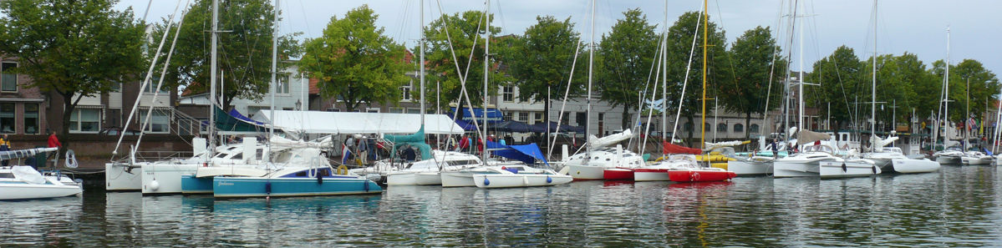

The Catamaran and Trimaran Club Nederland, the Dutch association of multihull sailors exists 50 years!
From Thursday July 5 till Sunday July 8 we want to celebrate this with a big festive gathering of multihulls in the cosy port of Hellevoetsluis. In the charming town at the Haringvliet we hope to welcome about 50 multihulls of all kinds.
The west side of the Haaven, from the lighthouse to the bridge is reserved for us. This is a long quay, where we can moor alongside.

The jubilee is planned at the start of the holiday season, to facilitate the boats to sail there, considering time and weather. This also makes the event a nice starting point for a holiday along the Belgian, French and English coast. Or nearby: a cruise in the estuary of Zeeland.

We think it will be a nice club- and sailing event with various activities and numerous guests and visitors to the colourful collection of multihulls along the quay.
There will be ample time for socializing and visiting each other’s boats. Meeting people with similar interest and passion and share experiences is one of the charms of such an event.
The multihull community is not limited to the Netherlands. Therefore we explicit invite sailors from our surrounding countries and hope that multihulls from Germany, Denmark, Belgium, England and hopefully France will find their way to Hellevoetsluis.

For the keen racers among us, we organize an attractive series of regattas on the Haringvliet for the Henk Eggink Troffee and the Zeelandkristal.

Our website www.ctcnederland.nl gives more detailed information about the event, in both Dutch and English and German (partly). Registration can be done under the chapter “Inschrijven”.

The CTC-50 team is looking forward to meet you all in the first weekend of July in Hellevoetsluis.

If the are any questions left after reading the website please contact us via regiozuid@ctcnederland.nl

